San Quentin Prison

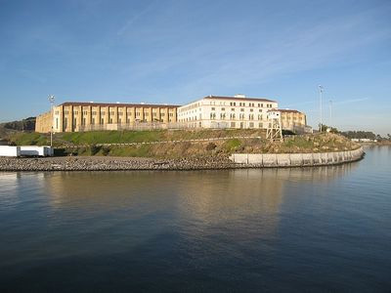<http://www.ttgcorp.com/wp-content/uploads/2011/06/San-Quentin-State-Prison-02.jpg>

Video Arial View <https://www.youtube.com/watch?v=yUHIIjl7kNE>

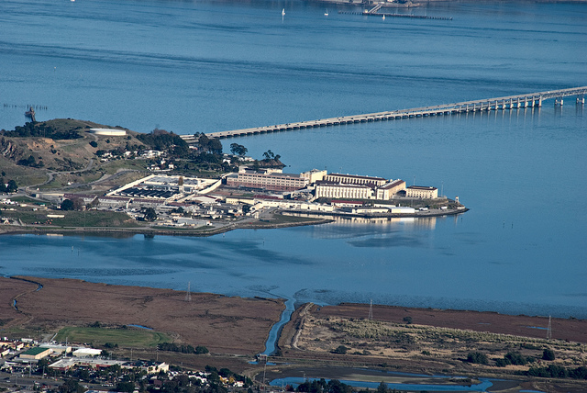 <http://kalw.org/post/san-quentin-radio-project-when-victims-and-offenders-talk>

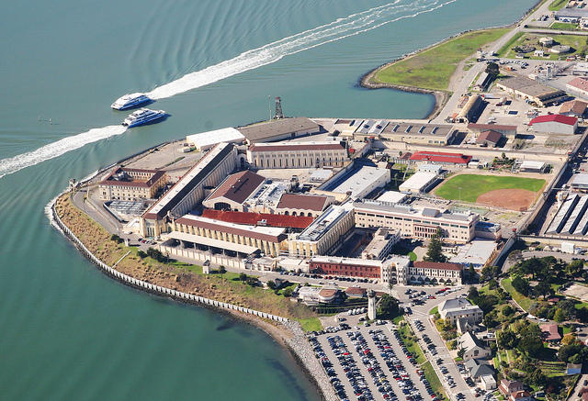 <http://kalw.org/term/san-quentin-prison-report>

Alcatraz Prison

 Type Font IDEA

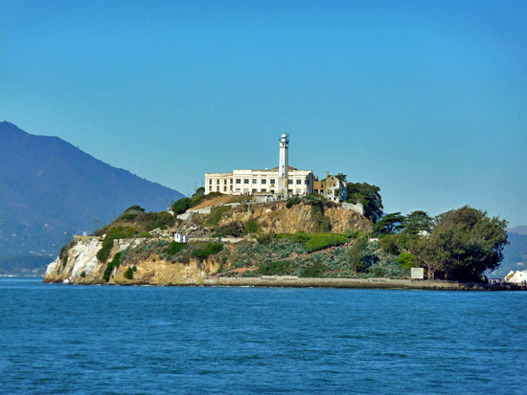 <http://thewanderkind.com/magic-san-francisco/>

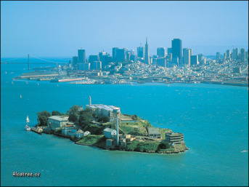 <https://montevallocomposition.wordpress.com/2012/02/19/alcatraz-2/>

Swim image

<http://www.sfgate.com/bayarea/article/Escape-From-Alcatraz-Triathlon-draws-almost-2-000-2369329.php>

San Francisco

 <http://thewanderkind.com/magic-san-francisco/>

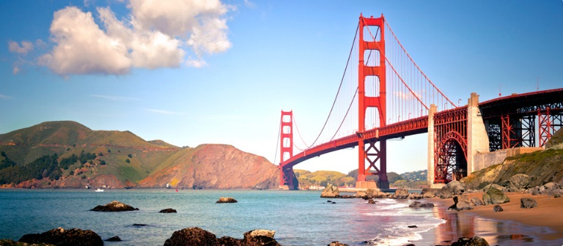 <http://www.jetblue.com/vacations/san-francisco-vacations/>

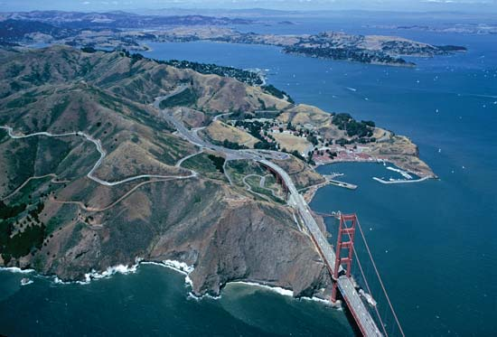 <http://www.britannica.com/EBchecked/media/172365/Aerial-view-of-the-Golden-Gate-Bridge-and-San-Francisco>



<http://www.1888freeonlinegames.com/iphonegames/prison-breakout-18082.html>